Node error code:

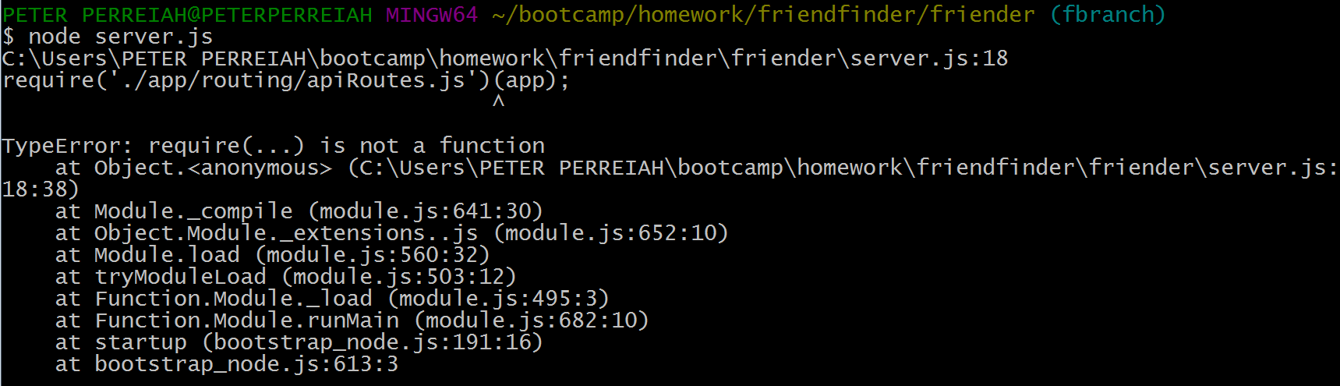

Here is my Server.js file:

(Note that require(‘./app/routing/apiRoutes.js’)(app); is the same syntax used in the Hot Restaurant example. App should be passing express to the require() here.)

